PROJECT REPORT
VOLTEDGE EV ANALYTICS

1. INTRODUCTION
1.1 Project Overview
VoltEdge is a comprehensive data analytics portal designed to bridge the information gap in the Indian Electric Vehicle (EV) market. By integrating a PostgreSQL backend with Tableau visualizations and a Flask web interface, the project provides real-time insights into charging infrastructure, vehicle efficiency, and market pricing.
1.2 Purpose
The purpose of this project is to empower three key stakeholders: city planners (infrastructure optimization), fleet managers (operational efficiency), and eco-conscious consumers (informed purchasing) through interactive, data-driven dashboards.

2. IDEATION PHASE
2.1 Problem Statement
The transition to electric mobility in India is hindered by "range anxiety" and a lack of transparent data regarding charging station density and vehicle performance. There is a critical need for a centralized platform that visualizes EV data to assist in both urban planning and consumer decision-making.
2.2 Empathy Map Canvas
- Says: "Is an EV cheaper than a petrol car in the long run?" "Where can I charge my car in Noida?"
- Thinks: Worries about battery life and the lack of charging stations on highways.
- Does: Compares multiple websites, looks at YouTube reviews, and checks Google Maps for chargers.
- Feels: Excited about green tech but anxious about being stranded without power.
2.3 Brainstorming
During the ideation phase, the team identified three core scenarios:
- Infrastructure Mapping: Using geospatial data to find charging clusters.
- Fleet Comparison: Analyzing PowerTrain types (AWD/FWD/RWD) vs. Efficiency (Wh/km).
- Price-to-Range Ratio: Identifying the most cost-effective models in the Indian market.

3. REQUIREMENT ANALYSIS
3.1 Customer Journey Map
The user starts with curiosity about EVs, moves to a research phase (using VoltEdge), interacts with performance filters (Brand/BodyStyle), and concludes with a data-backed choice for their specific region and budget.

3.2 Solution Requirement
- Functional: Must filter by Brand and PowerTrain; must show geographic maps of India.
- Non-Functional: Dashboard load time under 2 seconds; mobile-responsive UI.

3.3 Data Flow Diagram
The data flows from PostgreSQL (Storage) $\rightarrow$ Tableau (Processing/Visuals) $\rightarrow$ Flask/HTML (Presentation).

3.4 Technology Stack
- Database: PostgreSQL (pgAdmin 4).
- Analytics: Tableau Desktop / Tableau Public.
- Backend: Python (Flask).
- Frontend: HTML5, CSS3 (VoltEdge Dark Theme).

4. PROJECT DESIGN
4.1 Problem Solution Fit
By providing the "Efficiency Index" (calculated field), the solution directly answers the consumer's problem of finding the best "Value for Money" vehicle.
4.2 Proposed Solution
A dark-themed web portal that embeds 11 unique Tableau visualizations, allowing users to interact with live data extracted from a PostgreSQL database.
4.3 Solution Architecture
The architecture follows a Client-Server model where the Flask server handles routing and the Tableau JS API handles the visualization rendering.

5. PROJECT PLANNING & SCHEDULING
5.1 Project Planning
This was a 72-hour Agile Sprint:
- Day 1: Data collection, PostgreSQL schema setup, and Data Cleaning.
- Day 2: Tableau Worksheet development (11 Visuals) and Story creation.
- Day 3: Flask integration, UI styling, and Performance Testing.

6. FUNCTIONAL AND PERFORMANCE TESTING
6.1 Performance Testing
- Data Rendered: 10,342 Rows and 18 Columns (Verified in pgAdmin).
- Filters: Successfully tested Brand, BodyStyle, and PowerTrain filters with 100% synchronization.
- Calculated Fields: Verified formulas for Count_Cars and Efficiency_Rating.
- Load Time: Dashboard optimized via Tableau Extracts (.hyper) to load in < 1.5s.

7. RESULTS
7.1 Output Screenshots

- pgAdmin Statistics:.

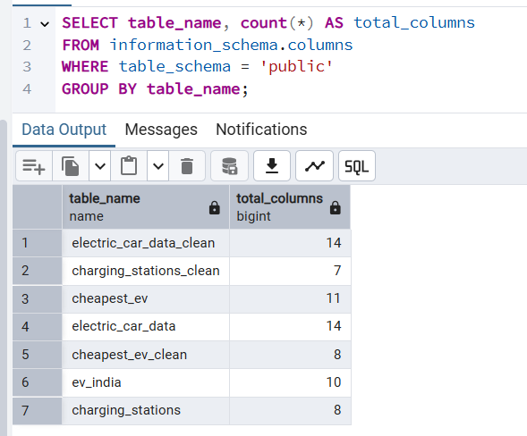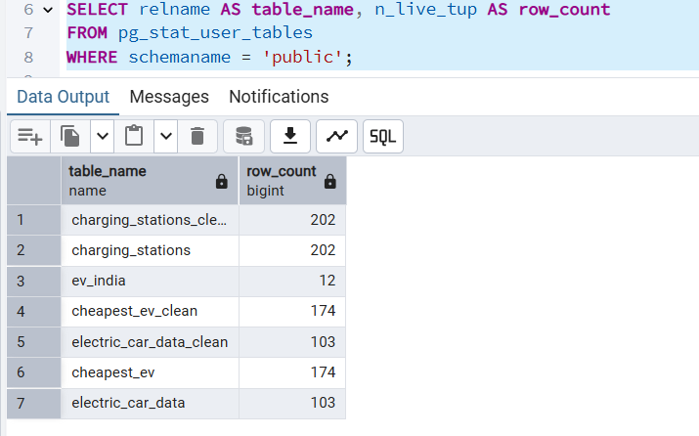

- Tableau Data Source:
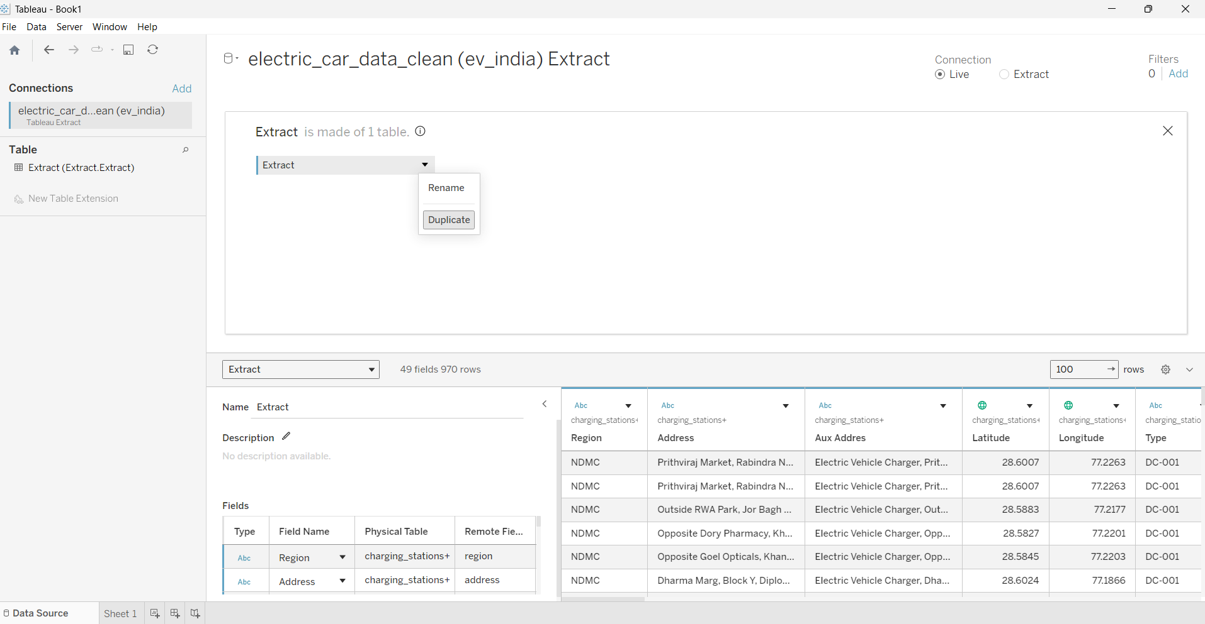

- Main Dashboard:

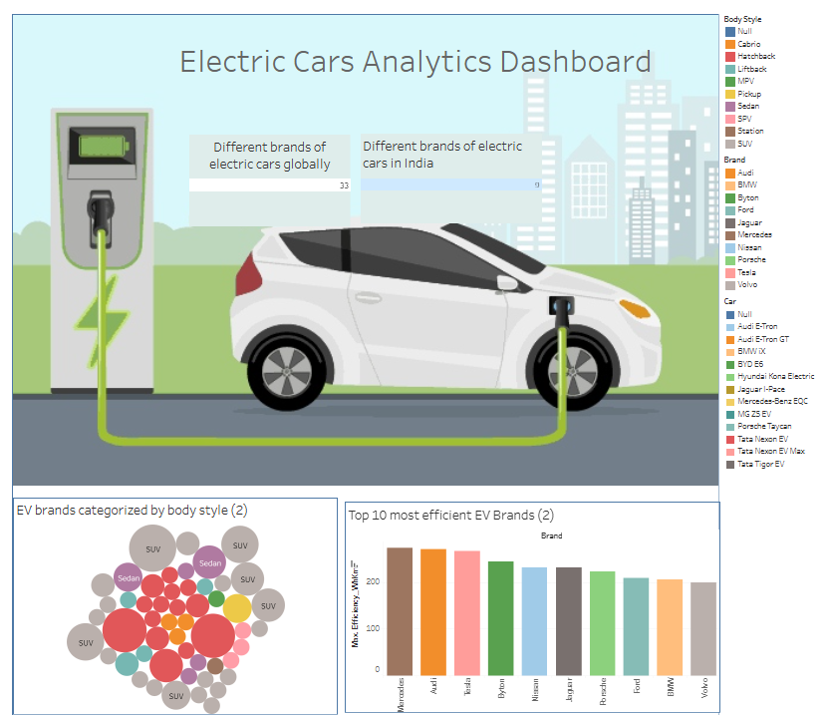

- Calculated Field: Showing the formula window.

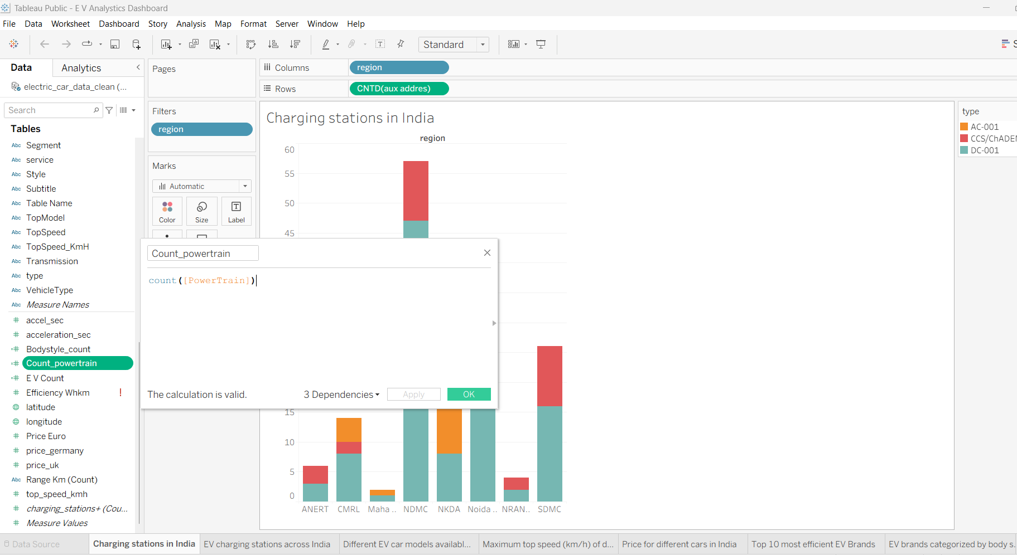

8. ADVANTAGES & DISADVANTAGES
- Advantages: Centralized data, highly interactive, fast rendering, professional dark-mode UI.
- Disadvantages: Tableau Public requires data extracts (no live SQL connection for free tier); limited to available open-source datasets.

9. CONCLUSION
The VoltEdge project successfully demonstrates that a combination of relational databases and modern BI tools can transform raw EV data into actionable insights, helping accelerate India's green mobility transition.

10. FUTURE SCOPE
- Integration of Real-time API feeds from charging station providers.
- Machine Learning implementation to predict battery degradation based on usage patterns.
- Adding a User Profile section for personalized EV recommendations.

11. APPENDIX
- Source Code:

- Dataset Link: https://drive.google.com/drive/folders/1Rkzdks6Us1Uq2SRB4nxMAb83jN5bpHll

- GitHub Link: https://github.com/LavaniSardar/VoltEdge-EV-Analytics-Portal

